DriverPass Business Requirements Document
Ashley Pleasant
CS 255 Systems Analysis and Design
Southern New Hampshire University

System Components and Design

Purpose
• Design a secure, cloud-based system for DriverPass that supports its driver-training services and can be accessed through a web browser on computers and mobile devices.
• Give customers access to online classes and practice tests, along with the ability to schedule, modify, and cancel reservations for on-the-road lessons.
• Give DriverPass employees the tools they need to register customers, manage appointments and accounts, assign drivers and vehicles, track student progress, and produce reports.
• Create one reliable source of current information so customers and employees are working with the same schedules, training records, and account data.

System Background
• DriverPass was created in response to the large number of people who fail their driving school tests and the limited tools available to help them prepare.
• The company plans to address this problem by combining online learning and practice exams with in-person instruction and behind-the-wheel training.
• Customers will select from three packages. Package One includes six hours of driving practice, Package Two includes eight hours and an in-person lesson, and Package Three includes twelve hours, an in-person lesson, online course material, and practice tests.
• The system will bring together customer registration, package enrollment, payment information, lesson scheduling, driver and vehicle assignments, student progress, driver notes, communication, and reporting.
• A connection to the driving school will help DriverPass receive updates to rules, policies, and sample questions so its training information stays current.

Objectives and Goals
• Allow each customer to use a secure account, enroll in an available training package, and automatically reset a forgotten password.
• Allow customers and the secretary to create, modify, or cancel lesson reservations and record the requested date, time, pickup location, and matching drop-off location.
• Schedule every driving lesson in a two-hour block and match the reservation with one available driver and one available vehicle.
• Track the hours included in each customer's package so the required number of two-hour lessons can be completed without exceeding the purchased hours.
• Provide eligible customers with online course material and practice tests and display each test's name, time taken, score, and status.
• Store driver notes for each lesson, including the lesson time, start hour, end hour, and comments.
• Apply role-based permissions for the owner, IT officer, secretary, drivers, and customers.
• Record who creates, changes, or cancels a reservation and allow authorized employees to print an activity report.
• Allow the owner to disable a package so new customers cannot register for it while past records remain available.
• Notify authorized employees when the driving school supplies updated rules, policies, or sample questions.
• Allow authorized users to download selected reports or information for offline work while preventing offline changes to the live system.

Requirements

Nonfunctional Requirements

Performance Requirements
• The system should be available through the web whenever customers or employees need to access it, except during announced maintenance periods.
• Common actions, such as logging in, viewing test progress, checking availability, and opening a reservation, should normally load within three seconds on a stable connection.
• Reservation, account, training, and payment-status updates should appear in the system immediately after a successful transaction so users do not work from outdated information.
• The system should prevent two customers from reserving the same driver or vehicle for overlapping lesson times.

Platform Constraints
• The system will be web-based and hosted in the cloud so DriverPass does not have to maintain its own servers, backups, or security infrastructure.
• The interface should work in current web browsers on desktop computers, laptops, tablets, and smartphones without requiring separate installed software.
• A centralized database is required to store customer, package, reservation, driver, vehicle, payment, test, and audit information.
• Users must be online to add or change live data. Downloaded reports may be viewed or edited offline, but those copies will not update the system automatically.
• The driving school connection depends on the data or integration method the driving school makes available.

Accuracy and Precision
• Each customer, employee, reservation, payment, vehicle, test attempt, and activity record should have a unique identifier.
• Required fields should be validated before information is saved. Dates, times, phone numbers, addresses, payment fields, and account credentials should use the expected format.
• The system should verify that pickup and drop-off locations match, as requested by DriverPass, and ask the user to correct the information when they do not.
• The scheduling process should check package hours and driver and vehicle availability before confirming a lesson.
• Practice-test records should accurately display the test name, time taken, score, and one of four statuses: not taken, in progress, failed, or passed.
• Audit records should store the user, action, affected record, and date and time for reservation creation, modification, and cancellation.

Adaptability
• The IT officer should be able to add, modify, reset, block, or deactivate user accounts without changing program code.
• The owner should be able to enable or disable an existing training package without deleting customer history connected to that package.
• The design should keep package, course, test, and scheduling information separate enough that developers can add or remove modules in a later release.
• Cloud hosting and browser-based access should allow routine operating-system and device updates without requiring a separate DriverPass installation.
• The system should allow updated driving school rules, policies, and sample questions to be reviewed and added without rebuilding unrelated parts of the application.

Security
• Every user should sign in with an individual account, and permissions should be based on the user's role.
• The IT officer should have full account-management access, including password resets and the ability to block access when an employee leaves.
• Customers should be able to use a secure self-service password-reset process.
• Connections between users and the cloud system should be encrypted, and sensitive stored data should also be protected through encryption and access controls.
• Repeated failed sign-in attempts should trigger a temporary lockout or additional verification to reduce brute-force attacks.
• Payment card data should be handled through a secure payment service. DriverPass should store only the information needed to confirm and track the transaction.
• The system should maintain audit logs and cloud-managed backups so authorized staff can investigate changes and recover information after a failure.

Functional Requirements
• The system shall validate user credentials during login and display functions based on the user's assigned role.
• The system shall allow the IT officer to create, modify, reset, block, and deactivate user accounts.
• The system shall allow customers to reset forgotten passwords through a secure automated process.
• The system shall store customer names, addresses, phone numbers, pickup locations, drop-off locations, and selected package information.
• The system shall allow authorized users to enroll a customer in one of the active training packages and record the related payment status.
• The system shall allow the owner to disable an existing package so it is unavailable for new enrollments.
• The system shall allow customers and the secretary to create, modify, and cancel driving lesson reservations.
• The system shall schedule driving lessons in two-hour blocks and assign an available driver and vehicle to each confirmed reservation.
• The system shall prevent scheduling conflicts involving customers, drivers, or vehicles.
• The system shall track the number of driving hours used and remaining in each customer's package.
• The system shall provide Package Three customers with online course content and practice tests.
• The system shall record the name, time taken, score, and status of each practice-test attempt.
• The system shall allow drivers to enter lesson start and end times and comments about the customer's performance.
• The system shall record the user who creates, changes, or cancels each reservation and the date and time of the action.
• The system shall allow authorized users to generate, print, and download activity and operational reports.
• The system shall receive or import driving school updates and notify authorized employees when new information is available.
• The system shall provide a contact page and allow authorized employees to contact customers using the information in their profiles.

User Interface
• The interface should use a consistent, easy-to-learn layout that works on both computers and mobile devices.
• Customers should have a dashboard for their profile, selected package, remaining driving hours, reservations, course material, practice tests, scores, and password reset.
• The reservation screen should show available dates and times and clearly identify the assigned driver and vehicle after confirmation.
• The secretary should have screens for registering customers, recording customer information, enrolling customers, accepting payment information, and managing appointments.
• Drivers should have a simple schedule view and a form for entering lesson times and comments.
• The owner should be able to view reports, review activity, monitor the business, and enable or disable packages.
• The IT officer should have an administrative dashboard for account maintenance, permissions, access blocking, and system support.
• Forms should identify required fields, check entries before submission, highlight errors, and explain how the user can correct them.
• The system should provide clear confirmation after registration, payment, reservation changes, cancellations, password resets, and test submissions.

Assumptions
• Customers and employees will have a supported device, a current web browser, and a dependable internet connection when they need to change live system data.
• DriverPass will begin with the three packages, ten vehicles, and two-hour driving sessions described in the interview, and the company will provide accurate driver schedules and package information.
• A cloud provider can supply routine backups, availability monitoring, and security, while DriverPass is responsible for user access and correct data entry.
• The driving school and payment provider will make reliable services or files available for updates and updating transactions.

Limitations
• The system will not allow users to change live records while offline. Downloaded reports are separate copies and may become outdated.
• Adding or removing complete modules or creating entirely new package behavior will require help from a developer or systems analyst. The first release only allows an existing package to be disabled.
• The system depends on internet access, cloud availability, the payment service, and the driving school update source. Outages or changes to those services may temporarily reduce functionality.
• Available lesson times are limited by DriverPass's number of drivers, vehicles, operating hours, and the two-hour lesson format.
• The first release is limited to the features from the interview. Future features would require additional requirements gathering, scheduling, and approval.

Gantt Chart
The schedule follows the dates, overlaps, priorities, and dependencies discussed in the DriverPass interview. Customer approval is completed before interface development begins, and the database, business logic, testing, delivery, and sign-off tasks follow in order.
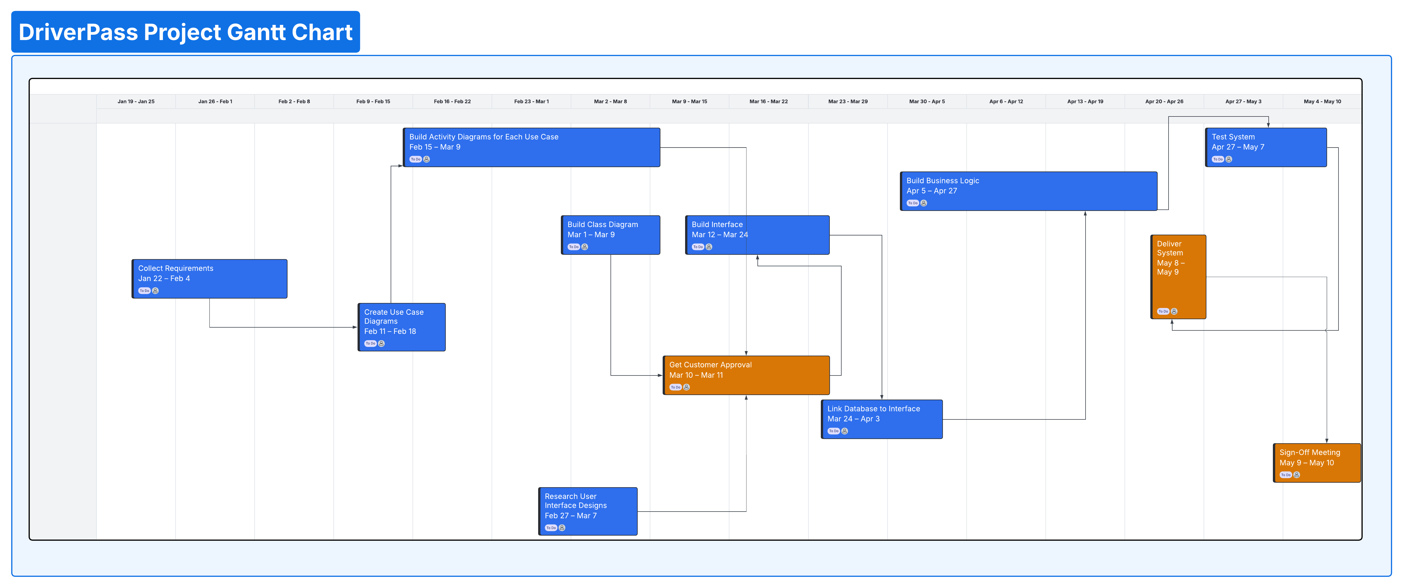
Figure 1 DriverPass Project Gantt Chart

